A Private View: Hockney
This week we were fortunate enough to attend the Rocket Food’s private view event. This took place in the iconic Tate Britain. An impressive venue which is home to the greatest collection of British art and is one of the most architectural rich venues in London.
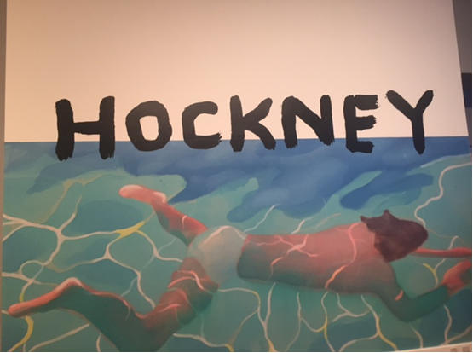
As we arrived we welcomed into the Sackler Octagon a magnificent architectural space in the heart of the Duveen Galleries. The space had been styled beautifully with up-lit coloured trees and an awe-inspiring UV light installation by Cerith Wyn Evans hung above. Either side of the room there was either bar or food station which had interesting colour block panels across them which fit nicely in the ‘arty’ theme of the evening.
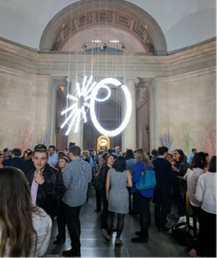
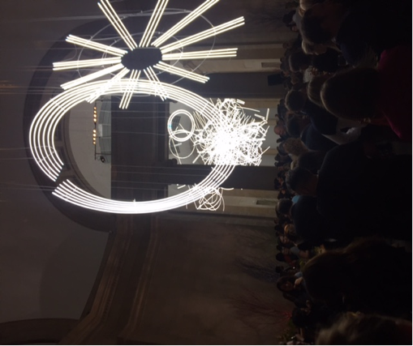

The art theme was carried out through the catering with the waiters in either pastel blue or pink shirts or canapes served on brightly coloured trays with fresh cut flowers. As for the food Rocket did not disappoint, we were treated to a selection of canapes and bowl food from Rockets new seasons menu.
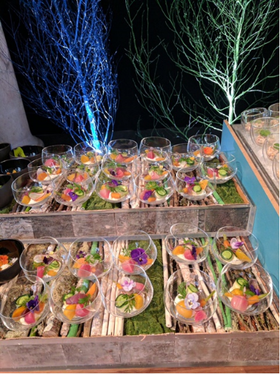
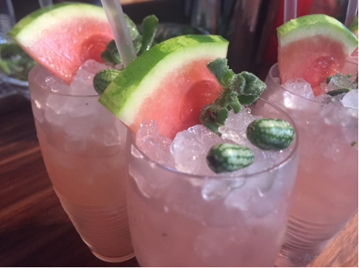
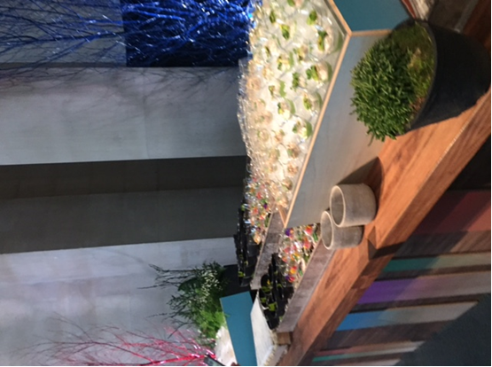
To put the cherry on the cake we were then allowed to peruse the David Hockney exhibition at our leisure. David Hockeny is one of today’s most popular and widely recognised artists and this exhibition gave us a snap shot of his work across the decades from 1960 to the present day.
Overall the evening was an absolute hit from start to finish with all attendees clearly enjoying themselves right to the very end!

